Experiment 1: Library Management System
AIM
To develop a Library Management System website that allows students to search books, register, log in, view borrowing history, check fines, and download study materials. It also allows the librarian to add, update, delete, issue, and return books.
SAMPLE CODE
<!DOCTYPE html>
<html>
<head>
<title>Library Management System</title>
<style>
body {
font-family: Arial;
background-color: #f2f2f2;
text-align: center;
}
h1 {
color: darkblue;
}
input, button {
padding: 10px;
margin: 5px;
}
button {
background-color: lightblue;
cursor: pointer;
}
#result {
margin-top: 20px;
color: green;
}
</style>
</head>
<body>
<h1>Library Management System</h1>

<h3>Search Books</h3>
<input type="text" id="book"
placeholder="Enter book name">
<button onclick="searchBook()">Search</button>
<h3>User Login</h3>
<input type="text" id="username"
placeholder="Enter username">
<button onclick="login()">Login</button>
<h3>Admin - Add Book</h3>
<input type="text" id="newBook"
placeholder="Enter new book name">
<button onclick="addBook()">Add Book</button>
<p id="result"></p>
<script>
let books = ["Java", "Python", "HTML"];
function searchBook() {
let name = document.getElementById("book").value;
let found = books.find(
b => b.toLowerCase() === name.toLowerCase()
);
document.getElementById("result").innerHTML =
found ? "Book Available: " + found
: "Book Not Found";
}
function login() {
let user = document.getElementById("username").value;
document.getElementById("result").innerHTML =
user ? "Welcome, " + user
: "Please enter username";
}
function addBook() {
let name = document.getElementById("newBook").value;
if (name.trim() !== "") {
books.push(name);
document.getElementById("result").innerHTML =
"Book Added Successfully: " + name;
} else {
document.getElementById("result").innerHTML =
"Please enter book name";
}
}
</script>
</body>
</html>
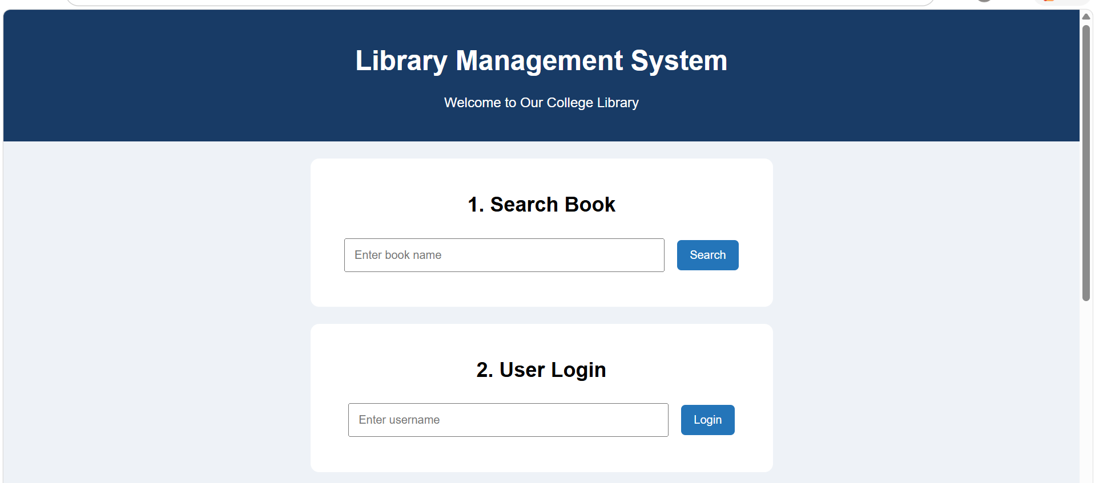
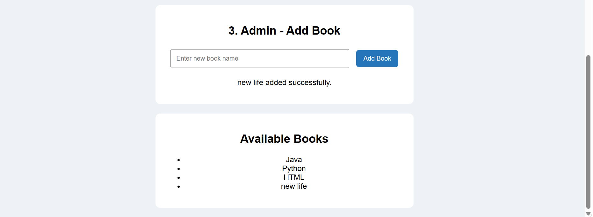
RESULT
Thus, the sample Library Management System website was developed successfully using HTML, CSS, and JavaScript. It supports basic book searching, username entry, and adding books.

